Intelligent Parking Management with IoT and RFID

|  |  |  |
| --- | --- | --- |
| Jyoti  Department of Computer Science And Engineering  Chandigarh University  Mohali, India  jyotikalra004@gmail.com | Anish Gupta  Department of Computer Science And Engineering  Chandigarh University  [Mohali, India](mailto:anishgupta32224@gmail.com)  [anishgupta32224@gmail.com](mailto:anishgupta32224@gmail.com) | Er. Hatesh Shyan  Department of Computer Science And Engineering  Chandigarh University  Mohali, India  cse.hatesh@gmail.com |

***Abstract*— The notion of "smart cities" has been very popular very recently. The theory of an intelligent city is becoming feasible due to the advancements brought about by the Internet of Things. IoT professionals are working tirelessly to increase the dependability and effectiveness of urban facilities. IoT is addressing issues including congestion on the roads, a lack of parking spaces, and roadway security. We describe an IoT-based intelligent parking system in this research. The IoT module for the proposed intelligent parking system is deployed on-site and is used to track and indicate the state of availability of every single one parking spot. Furthermore, an app for smartphones is offered, enabling users to check for parking spots and reserve a spot in accordance with that availability. A broad overview on the system's structure is also described in the article. The paper concludes with a discussion of the system's operation in the structure of an illustration that validates the accuracy of the proposed approach.**

***Keywords—- Intelligent Parking Management with IoT and RFID, Ultrasonic sensors, Parking lot, Reservation***

I.INTRODUCTION

Automobile searches result in enormous time and energy waste as well as major financial consequences. This is especially true for those who experience constant pressure to arrive on time. Numerous contemporary advancements are used by smart towns and communities to effectively manage and enhance resources. One of the most crucial assets that needs to be well-maintained is a modern parking lot.[1] The Internet of Things (IoT), that incorporated with apps, sensors, and other technology, in a fast developing world is essential for designing and creating cutting-edge concepts and innovations. IoT is now more necessary to assist people as well as to make tasks easier and smarter. IoT has demonstrated dramatically improved automation effectiveness and is more advantageous when it comes to business monitoring processes. It facilitates easier decision-making, saves both time and money and increases revenue and productivity. The real-time consumer-focused implementation of IoT in the industrial setting is what our suggested solution with smart parking and transit is for. This research main objective is to offer an intelligent, independent, Internet of Things-centered exterior parking system that offers straightforward, safe accommodation for cars.[2] The current environment of rapid growth in population and technological advancements makes parking cars more

necessary for meeting transportation demands, particularly in public areas. Through the reduction of traffic and parking accidents, this technology can improve driving convenience and security. Contrary with different public spaces and parking attendant systems, supermarkets have a low amount of space set out for parking lots. Parking fees are quite pricey in theaters, retail centers, train stations, and other locations, and they are extremely expensive in airports. People occasionally run into problems like not knowing where their car is parked correctly indoors or forgetting to pay their parking fine. It is necessary to manually examine proposed systems for blank spaces.[3]   
One cutting-edge paradigm that can assist in realizing cities that are smart is IoT. "A recognized communication protocol-based global network of interconnected entities, each uniquely addressable. To put it another way, it's a network of connections where devices and things communicate and exchange data. As they use the gathered data to make the best choice, the things and gadgets become intelligent objects or devices. The Internet of Things' (IoT) pervasiveness can help solve problems in smart cities, such as parking spots. It is possible to collect information on the availability of a parking spot using sensors. Sensors are able to be used to gather data regarding a parking space's availability and non-availability and to alert users of these things. Time is saved, gasoline consumption is decreased, carbon monoxide (CO) emissions from cars are decreased, and congestion in the roadways is decreased as a result.[4]

II.LITERATUREREVIEW

Parking is a crucial part of transportation systems and can impact people's first impressions of a destination. Insufficient parking can lead to disappointment and relocation, causing issues that affect both city people and drivers. Many programs fall short in their attempts to properly handle parking because of incomplete or flawed data analysis. In order to assist cities be designed more efficiently, an intelligent parking system for parking for public transportation can evaluate data and make recommendations for the necessary amount of parking spaces.[5] The Internet of Things, or IoT, has been widely studied and used in many different applications, such as intelligent parking systems. Urban regions' antiquated and ineffective traditional parking

systems cause traffic jams and accidents. Putting in place an Internet of Things (IoT)-based smart outdoor parking system can offer automobiles in public spaces orderly, practical, and secure parking.[6] Metropolitan parking facilities are among the resources that smart cities efficiently manage and improve with the help of contemporary technology. To solve parking problems, an intelligent parking management tool has been created. It offers a number of features, including the ability to search for parking spaces, make reservations, pay for them, receive notifications, view data, and monitor. This system detects parking availability and enhances the general quality of existence within cities by using sensors and IoT principles.[7] Utilizing innovative technologies, intelligent parking control maximizes parking spot use while minimizing traffic jams. In order to facilitate drivers in finding available parking spaces and easily locating their parked automobiles, the proposed Intelligent Parking Management System incorporates a sensor technology and mobile app.[8] Smart cities are gaining popularity due to the increasing demand for IoT technology, aiming to efficiently use resources and ensure data security and network management. One problem that can be solved using IoT in smart cities is car parking, which can enhance monitoring and management while saving time and reducing fuel consumption and CO emissions. This study suggests putting in place an Internet of Things (IoT)-based smart parking system that would let vehicles check and reserve parking spaces, increasing efficiency and having less of an ecological impact.[9] Researchers are focusing on solving smart city problems, including parking issues in university campuses. Ontologies are being used to address interoperability problems and facilitate information exchange between different systems, with a specific focus on developing an ontology for smart parking in university campuses using IoT.[10] The development of Internet-connected devices has inspired smart city designs, with a focus on smart parking to address issues of congestion and fuel wastage. In order to deliver continuous time parking information and enhance user experiences, the study suggests an intelligent parking system that leverages RFID and Internet of Things principles. It does this by employing nodes equipped with wireless and infrared sensors. By calculating wait times and recommending parking spots that are nearest to the user's present position, the system seeks to address the issue of disorganized parking.[11] Modern cities are experiencing a lack of parking places due to a rapid rise in automobile production and usage, especially during peak periods as well as weekends. To assist drivers in finding parking spots that exist, an Internet of Things (IoT)-based automobile parking management system is being created. Users can use the IoTGecko Platform to determine the availability of parking from anyplace via the system, which uses sensor nodes mounted onto every parking lot to continually track their state and communicates the details to a central server.[12] Indian cities are facing a severe shortage of parking spaces, with a large number of vehicles and limited parking facilities. This has led to difficulties in finding parking slots, resulting in

vehicles being parked on roads and causing inconvenience to pedestrians. To address this issue, an android application has been proposed that will help people find available parking slots based on their location and make digital payments for parking.[13] Metropolitan congestion caused by traffic is lessened and smart parking systems operate more efficiently when collective path-finding is employed. Congestion can be lessened and income can be raised by scheduling routes that accommodate many drivers and decreasing the amount of time that parking spaces are empty.[14] The Internet of Things (IoT) allows for simple to access non-internet objects from anywhere, and the Intelligent Parking Solution makes use of IoT to assist drivers in finding and monitoring available parking spaces. By cutting down on time and fuel lost looking for parking spaces, it promotes to a more environmentally friendly atmosphere by lowering its carbon footprint.[15] Vehicle parking is a major challenge for educational institutions in Saudi Arabia due to increasing enrollments and limited parking supply. Common problems include finding responsible individuals for damages to cars, locating owners of wrongly parked cars, and forgetting car park locations. To address these issues, an ANPR camera-based intelligent automobile parking tracking and administration system named CampusSense is being suggested and a mobile application for efficient monitoring and protection of parking facilities. Car parking in crowded cities is a major issue, causing traffic congestion, fuel consumption, and time wastage.

A proposed solution involves using roadside cameras to monitor parking spots, with a Convolutional Neural Network (CNN) analyzing street images to identify free spots. A mobile application is also developed to notify drivers about available parking spots and provide navigation. A system should be developed to warn drivers of available parking spaces in urban areas, replacing the manual method and lowering the need for humans while simultaneously launching a novel approach to route optimization that cuts down on traffic and decreases the amount of time it takes to locate parking. Metro areas' growing populations have exacerbated parking issues and high vehicle densities. This study proposes an integrated car parking system that reduces traffic congestion and wasted time by directing drivers toward the nearest traffic-free path when looking for available parking spaces.

III.METHODOLOGY

A.CURRENT METHODOLOGY

The current method seeks to automate the parking system at a mall or building by utilizing RFID, or Radio Frequency Identification, technology. Europe, Japan, and the USA have already implemented this smart parking system. This research project is easy to do and reasonably priced. Features of this intelligent parking system include the ability for users to verify the presence of parking spaces in the closest parking area and time savings to find availability of parking area nearby as it can be frustrating to look for parking in crowded areas, leading to wasted time and fuel consumption. As a

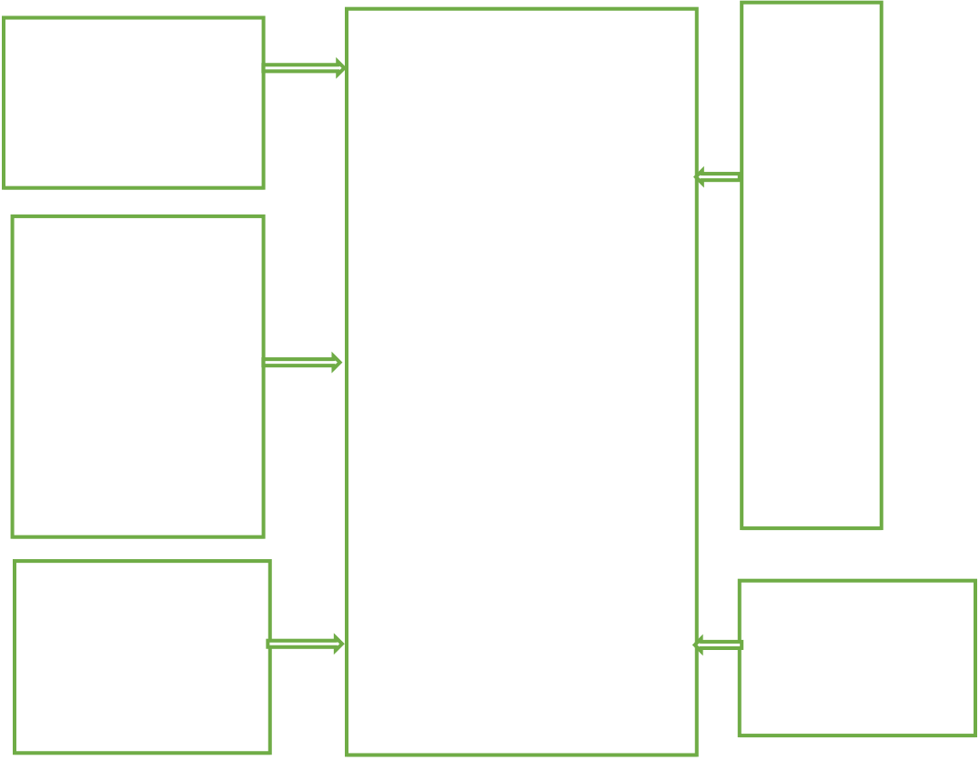

result, this system is expected to decrease fuel consumption, thereby reducing carbon emissions in the atmosphere. Many more facts concerning the Intelligent Parking Technology that should be emphasized along with to the issues already covered in the paper such as instantaneous monitoring by using a mobile app, customers can access the most recent information about free parking thanks to the Intelligent Parking System's continual monitoring of data in real time. Thanks to this function, drivers may make well-informed selections regarding parking locations based on availability right now. Also registration function by enabling customers to book parking spots via a mobile application ahead of time, the system lessens the uncertainty and anxiety related to locating a spot in a crowded area. This booking tool guarantees a smooth parking experience while improving the comfort of customers. Another is transaction integrity users can pay their parking costs digitally thanks to the Parking Management System's integration of a safe and practical payment gateway into the smartphone app. The parking procedure is made simpler with this cashless payment option, which also does away with the necessity for tangible methods of payment. Also alert systems via the mobile app, users can receive messages about the availability of parking spaces, booking assurances, payment receipts, along with other important details. Users can remain updated and involved in the parking network with the assistance of these messages. Moreover, versatility and adaptability as the Intelligent Parking System's modular structure makes it simple to expand in order to handle a boost in the quantity of customers and parking spots. Future additions of features and technologies can be seamlessly integrated into the system because to its versatile framework. Furthermore, customer feedback method as consumers may submit problems they have, offer suggestions for enhancements, and share their thoughts about their parking experiences through the software's feedback method. The communication loop aids in the system's ongoing improvement depending on customer demands and opinions.

smartphones. This could result in usability concerns and prevent the system from being widely adopted.

C.METHODOLOGY USED

In this new system two technologies IOT and RFID is used. We are using IOT in this smart parking system which provides availability of vacant parking area nearby thus reducing time for finding the parking area and also to avoid traffic at that area. To park a car, the user must present their RFID card at the entry gate, where a card reader is installed. The RFID card, in addition to its identification function, also holds information about the parking fees. The card reader records the entry time when the driver approaches the gate and transmits this useful information to the microcontroller. When the user go out of the parking area, the reader records the exit time. These entry and exit times are then used to calculate the parking fees.

|  |  |  |
| --- | --- | --- |
| RFID  READER | ARDIUNO UNO | L  C  D |
| IR  SENSOR |
| MOTOR | BUZZER |

Fig 1: Proposed Solution

|  |  |  |
| --- | --- | --- |
| i. | B.DRAWBACKS OF CURRENT METHODOLOGY | IV.RESULTS |
| Booking slots do not have a priority feature, and therefore, the system does not support the simultaneous booking of slots for multiple users. It is not possible to pre-booked slots which helps to minimize the traffic problems. Although this application is designed to be user-friendly, it does have a significant limitation when it comes to the payment gateway. Restricted Parking Lots Inclusion as the system's capacity for tracking and handling a specific amount of parking spots may be limited, making it difficult to provide details on availability for all parking lots in an entire town or at a certain location. Also networking problems reliance on mobile apps and IoT technology might result in issues with connectivity, including signal interruptions or network outages, that could affect the system's continuous tracking and reservation features. Consumer Acquisition Problems as some users may find it hard to utilize the platform efficiently, especially if they are not already comfortable using technology or apps for | The necessity for effective, immediate solutions in increasingly congested metropolitan areas is driving a significant increase in demand for smart parking systems. Users may rapidly find available parking spaces with the help of these smart technologies, cutting down on the time and expense of parking searches. Beyond just being convenient, these systems also significantly reduce fuel consumption, car emissions, and traffic congestion, improving the sustainability and pollution-free conditions of urban areas. Simplifying the parking process and improving overall urban mobility are two of the main benefits of intelligent parking systems. These devices save drivers the vexing and time-consuming task of looking for a spot by giving immediate information on parking availability.  Because fewer automobiles are circling the roads in search of parking, this not only lessens traffic congestion overall but also relieves individual stress. As a result, traffic moves more smoothly, especially in crowded city centres, which is |

advantageous for the whole transportation system. Intelligent parking solutions have a significant positive impact on the environment. These technologies help reduce fuel usage and greenhouse gas emissions significantly by reducing needless driving and idling. The implementation of smart parking systems is a natural fit for cities that are dedicated to sustainability and wider environmental objectives. Moreover, by integrating these systems with EV charging infrastructure, the usage of electric vehicles (EVs) can be encouraged, therefore lowering the carbon impact of urban transportation.Nevertheless, there are certain difficulties in putting these systems into place. Traditional parking operators can object to the installation because of the high upfront expenses and continuous maintenance requirements. Additionally, to maintain public confidence in the new technology, concerns around data security and privacy need to be carefully managed. To sum up, intelligent parking systems have several advantages that go well beyond just convenience. They mark a significant advancement in the creation of safe, effective, and sustainable urban environments. The use of smart parking technology will become more and more necessary as cities expand and the demand on parking spaces rises, laying the foundation for the urban areas of the future.

V.CONCLUSION

The Intelligent Parking System is based on the concepts of two powerful technologies that are IOT and RFID, it provides solution for current parking system. It is simple and cost effective which also reduces carbon footprints which are emitted during vehicle waiting for parking slots. It will also help in reducing man power in parking area and also help in reducing car thefts. Important elements to stress at the smart parking systems research work ultimately could be: It emphasize how the technology has improved user experience, decreased traffic congestion, and maximized parking space use. Moreover it provide customer reviews and positive remarks from consumers who enjoyed the advantages from the system's features.

Future Objective describe how you see the Intelligent Parking System fitting into the larger objectives of sustainable urban transportation and smart city development.

Call to Action to solve the escalating problems associated with industrialization and journeys, promote additional study, cooperation, and the application of automated parking alternatives. The idea of smart cities has long been an aspiration. Our forthcoming endeavor involves developing an intelligent parking system. This system will be equipped with a central authority that have access to all the necessary information that is managed by the intelligent parking system center. This access will be available to various management and control entities, such as the highway center, emergency center, traffic control center, and the police. Sensors within the system will continuously monitor vehicle availability and relay this data to parking meters. These meters will, in turn, transmit the updated information to the central information

hub. A number of extensions and improvements could be made to the intelligent parking system throughout the future to increase its application and effectiveness such as incorporation of Artificial Intelligence and Machine Learning (ML) by using AI algorithms, the system's capacity to forecast accessibility to parking can be improved by taking into account user behavior, previous information, and current variables like environment or activities. Additional Safety Specifications can increase general safety and prohibit illegal access to parking spots by using advanced safety technologies like biometric identification or vehicle registration recognition. Eco-friendly measures like encouraging the installation of charging stations for e- cars or providing incentives for carpooling might help the system meet objectives related to equitable urban growth. Also working together with various other smart city programs to integrate public transit or development initiatives for example, in order to create a smooth urban experience.

REFERENCES

[1]Y. Pankiv, N. Kunanets, O. Artemenko, N. Veretennikova and R. Nebesnyi, "Project of an Intelligent Recommender System for Parking Vehicles in Smart Cities," 2021 IEEE 16th International Conference on Computer Sciences and Information Technologies (CSIT), LVIV, Ukraine, 2021, pp. 419-422, doi: 10.1109/CSIT52700.2021.9648687.

[2]S. GokulKrishna, J. Harsheetha, S. Akshaya and D. Jeyabharathi, "An IoT based Smart Outdoor Parking System," 2021 7th International Conference on Advanced Computing and Communication Systems (ICACCS), Coimbatore, India, 2021, pp. 1502-1506, doi: 10.1109/ICACCS51430.2021.9441766.

[3]N. Farooqi, S. Alshehri, S. Nollily, L. Najmi, G. Alqurashi and A. Alrashedi, "UParking: Developing a Smart Parking Management System Using the Internet of Things," 2019 Sixth HCT Information Technology Trends (ITT), Ras Al Khaimah, United Arab Emirates, 2019, pp. 214-218, doi: 10.1109/ITT48889.2019.9075113.

[4]P. Melnyk, S. Djahel and F. Nait-Abdesselam, "Towards a Smart Parking Management System for Smart Cities," 2019 IEEE International Smart Cities Conference (ISC2), Casablanca, Morocco, 2019, pp. 542-546, doi: 10.1109/ISC246665.2019.9071740.

[5]M. Assim and A. Al-Omary, "A survey of IoT-based smart parking systems in smart cities," 3rd Smart Cities Symposium (SCS 2020), Online Conference, 2020, pp. 35-38, doi: 10.1049/icp.2021.0911.

[6]S. D. Nagowah, H. B. Sta and B. A. Gobin-Rahimbux, "An Ontology for an IoT-enabled Smart Parking in a University Campus," 2019 IEEE International Smart Cities Conference (ISC2), Casablanca, Morocco, 2019, pp. 474-479, doi: 10.1109/ISC246665.2019.9071751.

[7]D. pandey and S. Hanchate Author, "Navigation based - Intelligent Parking Management System using Queuing theory and IOT," 2018 Second International Conference on Green Computing and Internet of Things (ICGCIoT), Bangalore, India, 2018, pp. 159-165, doi: 10.1109/ICGCIoT.2018.8753053.

[8]N. Jusat, A. A. Zainuddin, R. Sahak, A. B. Andrew, K. Subramaniam and N. A. Rahman, "Critical Review In Smart Car Parking Management Systems," 2021 IEEE 7th International Conference on Smart Instrumentation, Measurement and Applications (ICSIMA), Bandung, Indonesia, 2021, pp. 128-133, doi: 10.1109/ICSIMA50015.2021.9526322.

[9]S. Kazi, S. Khan, U. Ansari and D. Mane, "Smart Parking based System for smarter cities," 2018 International Conference on Smart City and Emerging Technology (ICSCET), Mumbai, India, 2018, pp. 1-5, doi: 10.1109/ICSCET.2018.8537281.

[10]C. Rhodes, W. Blewitt, C. Sharp, G. Ushaw and G. Morgan, "Smart Routing: A Novel Application of Collaborative Path-Finding to Smart Parking Systems," 2014 IEEE 16th Conference on Business

|  |  |  |
| --- | --- | --- |
| Informatics, Geneva,  10.1109/CBI.2014.22. | Switzerland, | 2014, pp. 119-126, doi: |

[11]M. Meenaloshini, J. Ilakkiya, P. Sharmila, J. C. Sheffi Malar and S.   
Nithyasri, "Smart Car Parking System in Smart Cities using IR," 2019   
3rd International Conference on Computing and Communications   
Technologies (ICCCT), Chennai, India, 2019, pp. 178-182, doi:   
10.1109/ICCCT2.2019.8824953.

[12]M. Y. Aalsalem and W. Z. Khan, "CampusSense — A smart vehicle   
parking monitoring and management system using ANPR cameras and   
android phones," 2017 19th International Conference on Advanced   
Communication Technology (ICACT), PyeongChang, Korea (South),   
2017, pp. 809-815, doi: 10.23919/ICACT.2017.7890230.

[13]S. Gören, D. F. Óncevarlk, K. D. Yldz and T. Z. Hakyemez, "On-Street   
Parking Spot Detection for Smart Cities," 2019 IEEE International   
Smart Cities Conference (ISC2), Casablanca, Morocco, 2019, pp. 292-  
295, doi: 10.1109/ISC246665.2019.9071760.

[14]T. Rajendran, P. J. S. Kumar, A. Karthikeyarn, S. Balaji, B. R. T. Bapu   
and P. Varnikhaa, "Secure Model for Smart Car Parking System using   
Web Application," 2022 4th International Conference on Smart   
Systems and Inventive Technology (ICSSIT), Tirunelveli, India, 2022,   
pp. 138-143, doi: 10.1109/ICSSIT53264.2022.9716235.

[15]B. K. Patil, A. Deshpande, S. Suryavanshi, R. Magdum and B.   
Manjunath, "Smart Parking System for Cars," 2018 International   
Conference on Recent Innovations in Electrical, Electronics &   
Communication Engineering (ICRIEECE), Bhubaneswar, India, 2018,   
pp. 1118-1121, doi: 10.1109/ICRIEECE44171.2018.9008662.